Cloud Computing

**Name:** Jerusha Angel K

**Register No**: 727721EUCS049

Day-8

**Day 8_CF_CE1**

**Content Description:**

Host a static website in AWS using S3 bucket and CloudFront

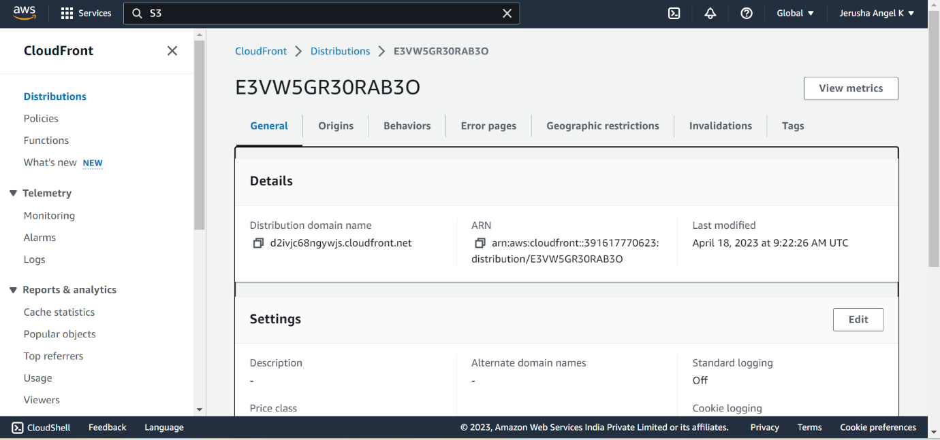

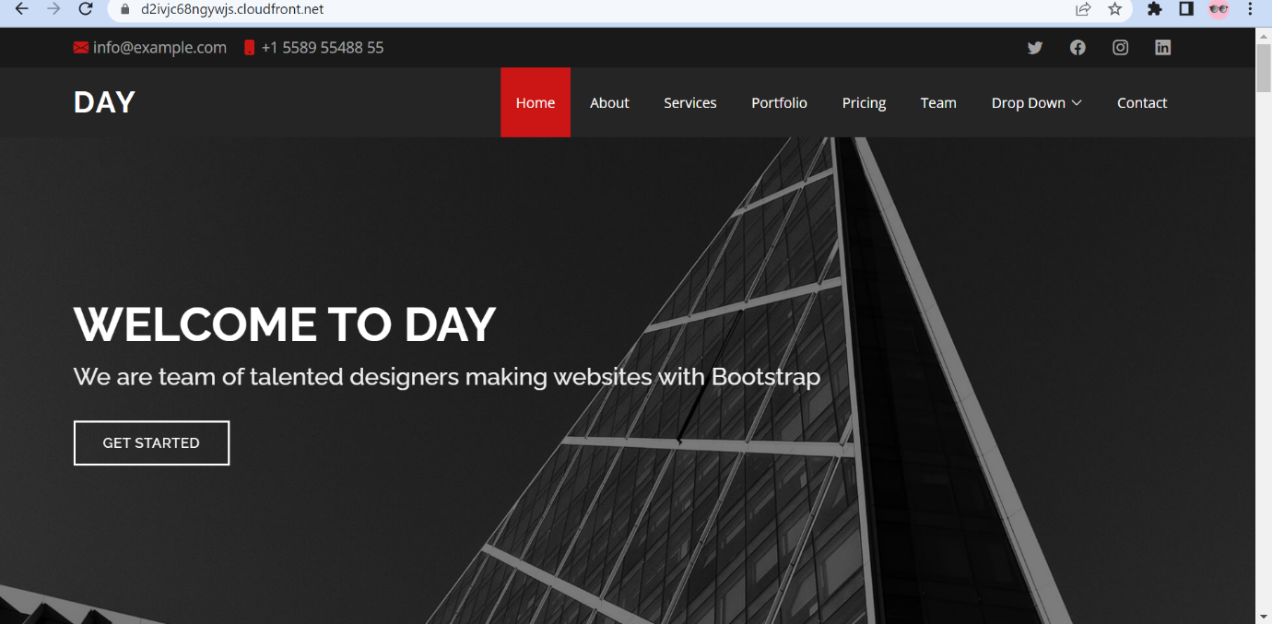

**Day 8_CF_CE2**

**Content Description:**

Host a dynamic website in AWS using EC2, ELB and CloudFront

